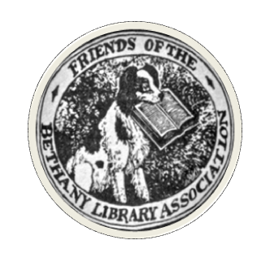
ANYONE CAN BE A FRIEND!
Sign up below to become a Member of the Friends.
This form can be returned as an email attachment to ClarkMain@bethanylibrary.org,
or mailed to the Friends c/o Clark Memorial Library at 538 Amity Road, Bethany, CT 06524.

Name _________________________________________ Phone _______________________________
Street Address __________________________________ Email ________________________________
Town _________________________________________ State ____________ Zip _______________

Yes, please consider me for help with…
Library Mini-Golf Event: ______________
Book sorting and organizing: ______________
Baking for fund-raising bake sales: ______________
Other program or fund-raising ideas – please specify: ________________________________________
_____________________________________________________________________________________

